LIST OF REVIEWERS

S/No | Name | Affiliation | Area of specialisation | Email address | Status
1. | Prof. Abdulwahab Giwa | Federal University Dutsin-ma | Chemical Engineering | agiwa@fudutsinma.edu.ng | Accepted
2. | Prof. Okewale Akindele | FUPRE | Petroleum/Chemical Engineering | okewale.akindele@fupre.edu.ng | Accepted
3. | Adaobi Stephenie Nwosi-Anele | Rivers State University | Petroleum Economics | adaobi.nwosi-anele@ust.edu.ng | Accepted
4. | Bright Bariakpoa Kinate, | Rivers State University | Petroleum and natural gas Production | kinate.bright@ust.edu.ng | Accepted
5. | Engr. Isaac Ihua- Maduenyi | Rivers State University | Reservior Engineering | isaac.ihua-maduenyi@ust.edu.ng | Accepted
6. | Dr. Abdullahi Adamu | Newcastle University | Chemical Engineering | abdullahi.adamu@newcastle.ac.uk | Accepted
7. | Prof. Folade Gbenga | University of Ibadan, Oyo State | Petroleum Energy economics and law | falodelias@gmail.com | Accepted
8. | Professor Samuel T. Wara | Edwin Clark University, Kiagbodo | Energy management | docwarati@gmail.com | Accepted
9. | Prof. Adenike Ogunshe | University of Ibadan | Biotechnology/Microbiology | adenikemicro@gmail.com | Accepted
10. | Prof. Oludele Awodele | Babcok University | Artificial Intelligence and computing | awodeleo@babcock.edu.ng | Accepted
11. | Dr. Morgan Akpan | African University of Science and Technology, | Geology | leo@aust.edu.ng | Accepted
12. | Dr Jasper Ahamefula Agbakwuru | Federal University of Petroleum Resources Effurun | Offshore and Underwater Engineering | agbakwuru.jasper@fupre.edu.ng | Accepted
13. | Opeyemi Oni | University of North Dakota. | Energy and Petroleum Engineering | opeyemi.oni@und.edu | Accepted
14 | Dr Thaddeus Chidiebere Nwaoha | Federal University of Petroleum Resources Effurun | Offshore and Underwater Engineering | nwaoha.thaddeus@fupre.edu.ng | Accepted

PROFILE OF REVIEWERS

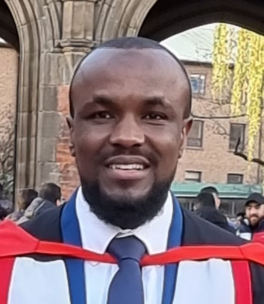
Engr. Abdullahi holds a B.Sc. and M.Sc. in Chemical Engineering from Mendeleev University of Chemical Technology of Russia, and a Ph.D. in Chemical Engineering from Newcastle University. His research focuses on process intensification, with expertise in catalysis, reaction engineering, and process engineering. He has contributed to the development of sustainable technologies for carbon capture and conversion, biorefining, gas sweetening, and wastewater treatment.

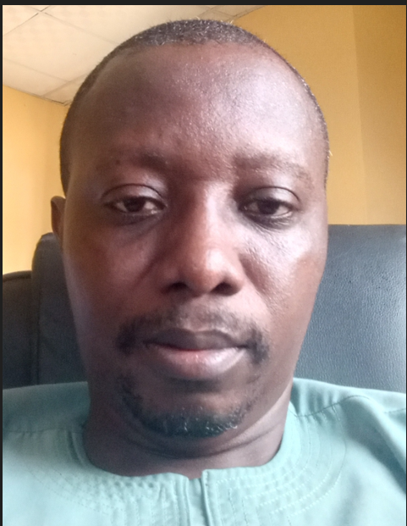
Prof. Akindele Oyetunde Okewale is a Professor in the Department of Chemical Engineering at the Federal University of Petroleum Resources, Effurun, Delta State. His work focuses on corrosion studies, separation processes, and renewable energy, with expertise in converting waste biomass into value-added products such as biofuels, bioethanol, and corrosion inhibitors. He is a registered engineer certified by COREN in Nigeria.


Engr. Isaac Eze Ihua-Maduenyi is a Lecturer in the Department of Petroleum Engineering at Rivers State University, Nigeria.He holds an M.Eng. in Petroleum Engineering from the Federal University of Technology, Owerri. His research interests include Petroleum Production Engineering and Production Optimization, and he has co-authored several publications in reputable journals.


Prof. Samuel T. Wara, PhD, FIMC, CMC, FNSE, FIET, R.Eng (COREN) is a Professor of Energy and Power Systems and an Energy Management Consultant. His expertise covers renewable energy, power systems, and energy management, and he has contributed extensively to research, innovation, and professional practice. Prof. Wara is a fellow of several professional bodies, including the Nigerian Society of Engineers (NSE) and the Institution of Engineering and Technology (IET).

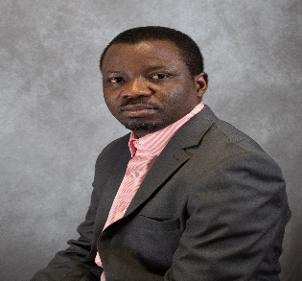
Dr. Opeyemi Oni is a petroleum engineer and researcher. His expertise spans drilling fluid design and optimization, drilling engineering, production technology, and geothermal heat extraction. Currently at the University of North Dakota, his work focuses on developing novel and waste-derived materials to improve drilling fluid performance using advanced analytical techniques.

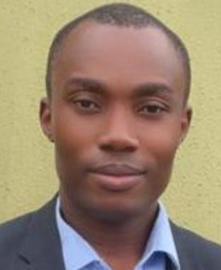
Engr. Bright Bariakpoa Kinate is a lecturer in the Department of Petroleum Engineering at Rivers State University, Nigeria. His academic and research contributions span flow assurance, CO₂ sequestration, produced water treatment, alkaline–surfactant–polymer flooding, corrosion inhibition, and crude oil emulsion treatment.

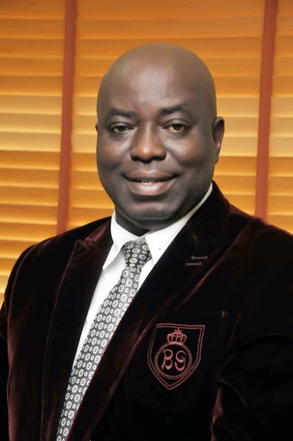

AWODELE Oludele is a Professor of Computer Science and Artificial Intelligence in the School of Computing, Babcock University, Ilisan-Remo. His current research is on Artificial Intelligence, Blockchain Technology, Data Communications and Computer Security.


Jasper Ahamefula Agbakwuru
Dr Jasper Ahamefula Agbakwuru is a Professor of Offshore Engineering and Underwater Technology in the Marine Engineering Department at Federal University of Petroleum Resources. He is an experienced academic and engineering professional with expertise in offshore engineering, subsea systems, underwater technology, sustainable energy, and ocean engineering. His research focuses on blue economy technologies, ocean renewable energy, climate change engineering, AI applications in offshore systems, and oceanography.

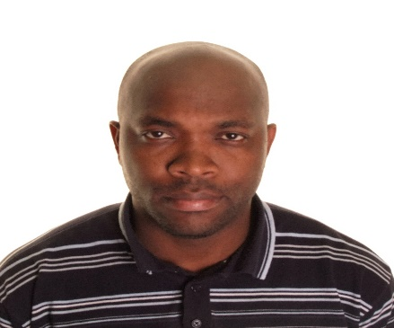

Thaddeus Chidiebere Nwaoha
Dr. Thaddeus Chidiebere Nwaoha is a Professor of Marine and Offshore Engineering System Reliability in the Marine Engineering Department, College of Engineering and Technology, at Federal University of Petroleum Resources. He holds a Ph.D. in Marine and Offshore Engineering from Liverpool John Moores University, in addition to MSc and B.Eng. degrees obtained in the United Kingdom and Nigeria respectively. His research interests include marine and offshore engineering systems reliability, offshore system design, failure analysis, safety engineering, and uncertainty modelling using artificial intelligence.

NAMES AND ADDRESSES OF POTENTIAL ADVISORY BOARD MEMBERS FOR PTI JOURNAL OF JHST
ADVISORY BOARD MEMBERS

S/NO | NAME | AFFILIATION | AREA OF SPECIALIZATION | EMAIL | Status
1. | Dr David Hitchmough PhD MEng AMRINA AFHEA | Research Fellow in Maritime Decarbonization  School of Engineering | Mechanical Engineering | D.M.Hitchmough@.ljmu.ac.uk | Accepted
2 | Prof. Ayansi Francis Ifeanyi | Ambros Alli University, Ekpoma, Edo State | Electrical and Electronics Engineering | francisanyasi@aauekpoma.edu.ng | Accepted
3 | Jasper Agbakwuru | Federal University of Petroleum resources, Effurun | Offshore/Subsea Engineering | agbakwuru.jasper@fupre.edu.ng  08106891639 | Accepted
4 | Dr Michael A. Adegbite | Petroleum Training Institute (Retiree) | corrosion engineering | adegbite_ma@pti.edu.ng | Accepted
5 | Dr. Kevin I. | Petroleum Training Institute (Retiree) | chemistry/polymer chemistry, | kiidehen@yahoo.com | Accepted

Thematic areas for the journal
1. Exploration, Production, and Operations (Upstream, Midstream, Downstream)
2. Health, Safety, and Environment (HSE) Management
3. Renewable Energy Integration Technologies
4. Transportation, Logistics, and Gas Flare Commercialization
5. Innovations in R&D, Digital Tech, and AI/Robotics
6. Asset Protection, SCADA, IoT, and Remote Monitoring
7. Energy Trading, Risk Management, and Financing
8. Sustainability, Environmental Management, and CCUS
9. Geology, Geophysics, and Mineral Exploration
10. Offshore Drilling and Subsea Engineering
11. Human Capital and Workforce Development
12. Regulatory, Legal, and Policy Frameworks
13. Market Trends and Strategic Outlook
14. Unconventional Resources and Energy Security
15. Collaboration and industry partnerships

PROFILE OF EDITORIAL BOARD MEMBERS
Prof. Francis Anyasi, PhD, M.Eng, B.Eng, FNSE, R.Eng (COREN) is a Professor of Telecommunication Engineering at Ambrose Alli University, Ekpoma, Edo State, Nigeria. He has extensive academic and professional experience in telecommunications engineering and has contributed to advancing research and practice in the field. Prof. Anyasi is a COREN-registered engineer and a Fellow of the Nigerian Society of Engineers (NSE).

